Linux File System

File System explains directory structures, different commands, and logic expressions.
into directories and sub directories.

A file system is an architecture defining how files are stored and retrieved. The Linux file system is the structure that the Linux operating system uses to organize and store files and data on a computer. It is a hierarchical, tree-like structure that starts with the root directory, which contains all other directories and files, it is based on the Unix file system.

History of windows and Linux

- Windows initially evolved from MS-DOS(disk operating system) that worked on command-line interaction only.
- Overtime Windows became a graphical user interface(GUI) , built on top of MS-DOS
- Windows initially assigned removable floppy drives letter A,B,C. As hard drives become common, the primary hard drives was assigned letter C
- Linux on the other hand follows UNIX tradition and based on command-line interface .
- LINUX is case sensitive file structure
- Mac’s background is also around UNIX, so its similar to Linux
- File Hierarchy standard defines the structure and layout

Linux uses the Filesystem Hierarchy Standard (FHS) file system structure, which defines the names, locations, and permissions for many file types and directories.
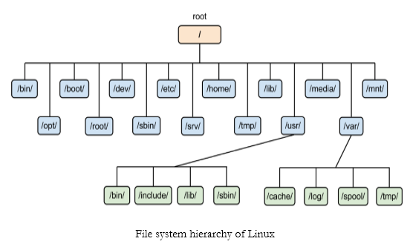

/bin
- contains basic binaries/ programs used by all users like ls,cat.

/sbin
- similar to /bin but it holds system administration meant for use by administrator.

/boot
- contains files necessary for the system booting process such as: kernel.

/cdrom
- represents the cd and dvd drive

/dev
- contain files representing devices connected to systems like hard drives.

/etc
- holds system wide configuration files and services and applications

/lib,/lib32,/lib64
- these directories stores library files required for programs to run correctly.

/mnt,/media
- these are used to temporarily mount external devices like USB drives, DVDs.

/opt
- It stands for “options”. It is used for installation of software packages that are not a part of system installation

/proc
- contains virtual files that provide information about running process and system setting.

/root
- the home directory for the super user of the system.

/run
- contains temporary run time data that specify the current system session

/snap
- used by snap package management system to maintain software packages

/srv
- "service" . intended for storing data files related to specific services or applications running on the system.

/sys
- allows interaction between system and devices connected

/tmp
- temp files created by application or the system.Files are usually cleared on System restart.

/usr
- contains user relaed files, including user programs, libraries, documentation, and other resources.

/var
- “variable” contains variable data files, such as log files, spool files, temporary mail files, and cached data.

/home
- contains personal user directories, where each user has self sub dir

